UPDATE ON EBOLA VIRUS IN SIERRA LEONE & LIBERIA
IMC
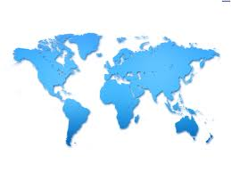
BRIDGE OF HOPE PROJECT

OCT.10, 2014
Churches and Christian NGOs have increased their level of sensitization and contribution to EBOLA VIRUS VICTIMS in both Sierra Leone and Liberia.
IMC BRIDGE OF HOPE TEAM for the last two weeks carried out awareness and sensitization in many communities such as NEWTON,REGENT,IMATT,SORIE TOWN,LUNGI,WILBERFORCE ,KAMAYAMA,KONDIE FARM ETC. and distributed preventive kits and food.
MORE ITEMS WILL BE DISTRIBUTED by the bridge of Hope team NEXT WEEK TO PARENTS,GUARDIANS ,STUDENTS and wards OF KONDIE FARM AND NEWTON SCHOOLS, HILL COT ROAD , UPPER WELLINGTON AND KISSY..(these include churches and various families and communities )
THANKS TO ALL OF YOU WHO GAVE GIFTS TO BE ABLE TO REACH MANY COMMMUNITIES AND FAMILES. Your gifts( to purchase food and prevention kits) will help to prevent the ebola virus from spreading and killing more families.
THANKS ALSO TO Bro. Karlin Bacher who sent the team a training Doc for Ebola sensitization and awareness campaign…which is now being used in various areas by the BRIDGE OF HOPE TEAM…
A SPEECH FROM THE PRES. OF SL in the UK to the World bank’s high level round table “ The honest nature of Sierra Leone's Head of State which has endeared him to many, was glaring to all on October 9th 2014, when in his address to a major international forum.”

President Koroma told the World Bank's high level Round Table meeting that SL c had recorded over 2,500 cases of Ebola infections but has only 530 survivors so far.
According to the Pres. below are the physical facts on the ground that must be urgently deployed in our race against the virus:

1. A Community Ebola Care and Holding Centre comprising 20 beds in each of our 149 chiefdoms and 20 centres in the Western Area, giving a total of 169

2. Treatment Centers: the country requires, strategically placed treatment centers holding a total of 1500 more beds.

3. Personnel: The 1500 additional treatment center beds would require a recommended number of 5250 health personnel including 750 doctors, 3000 nurses and 1500 other support staff of hygienists, counselors, and nutritionists. The Community Care Ebola Centres also need trained health workers with medical doctors supervising a cluster of them.

3. Equipment and Logistics: These include PPEs, IV fluids, anti-bodies for super imposed infections, food supplies, 200 ambulances to service the nationwide network of treatment centres, and community Ebola care units, 1000 motor bikes for contact tracers and two hundred 4WD utility vehicles for supervisors, surveillance officers, and burial teams.

4. Laboratories: There are currently four customized Ebola labs in the country able to do less than 150 samples per day. We need five more labs strategically located in the country …..

5. Funds for Incentives and other Expenses: Millions of dollars are also required to pay the thousands of health workers that would be deployed; millions of dollars are needed to shore up drug, food and other basic supplies and logistics.

6. Psychosocial Support: The Ebola outbreak is devastating for children and women and communities and these would need psychosocial support; orphans would need care, widows require support, and survivors help with meeting the challenges of stigmatization.

7. Other Support Services: The fight requires communication support to facilitate contact tracing, transmission of lab results, and general logistics chain management.

I.SIERRA LEONE

DISCHARGED CASES
• Total Survived and Released Patients = 538

NEW CASES
• New Confirmed cases = 93 as follows: Kailahun =1, Kenema= 0,
Kono = 1, Bombali = 25,
Kambia = 1, Koinadugu = 0,
Port Loko =2, Tonkolili = 14
Bo =1, Bonthe=0, Moyamba = 1, Pujehun = 0, Western Area = 47

CUMULATIVE CASES = 2,596
Kailahun = 533,
Kenema = 431,
Kono =26
Bombali = 333,
Kambia = 22,
Koinadugu =0,
Port Loko = 350,
Tonkolili = 114
Bo = 118,
Bonthe = 1,
Moyamba = 69,
Pujehun = 24
Western Area = 575
"The capital, Freetown, and the neighbouring districts of Bombali, Port Loko, and Moyamba, have all reported a surge in cases over the past seven to eight weeks.
"The districts of Bo and Tonkolili have also reported an increase in the number of new confirmed and probable cases over the same period. By contrast, a low number of new cases have been reported from Kailahun... and Kenema... for the past four weeks.
"These areas had previously reported high levels of transmission. Reports from responders suggest this fall is a genuine decline in incidence, although further investigation will be required before this can be confirmed."
More than 100 members of the British Army's 22 Field Hospital are preparing to provide a 12-bed treatment unit for healthcare workers in Sierra Leone.
On Wednesday 8th October the Pres. received the Cuban delegation of One Hundred and Sixty-Five medical (165) staff including doctors and nurses at State House. The delegation was led by the Cuban Ambassador to Sierra Leone resident in Accra, Ghana, Mr. Jorge F. Lefebre Nicolas.
The delegation comprises Sixty-Three (63) doctors and One Hundred and Two (102) nurses and professionals.
HERE ARE FEW OF THE PICTURES OF ITEMS DISTRIBUTED BELOW :
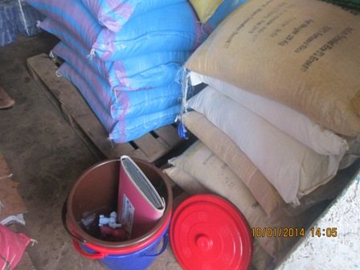
RICE BOUGHT
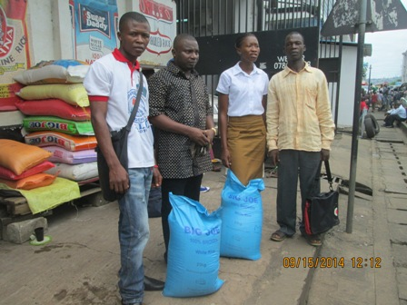
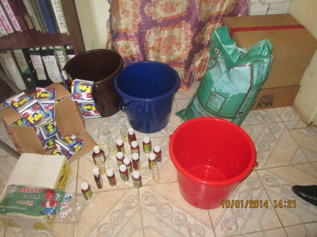
PREVENTION KITS
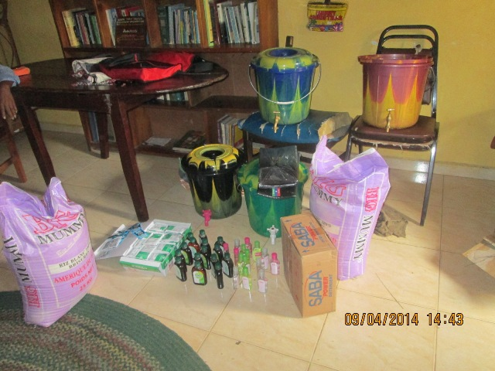
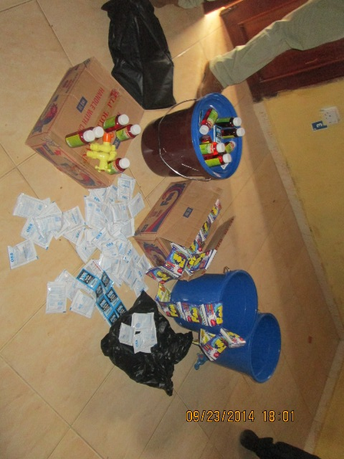

TEAM DEMONSTRATING HOW TO USE KITS
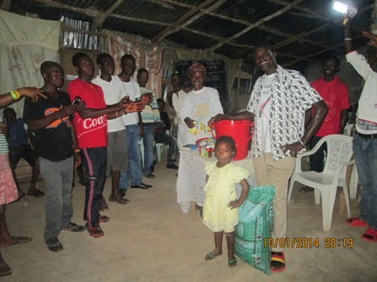
IMATT DISTRIBUTION

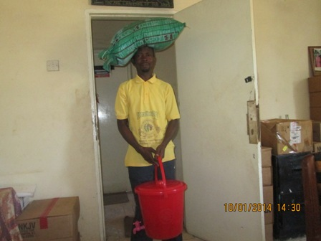
REGENT DISTRIBUTION
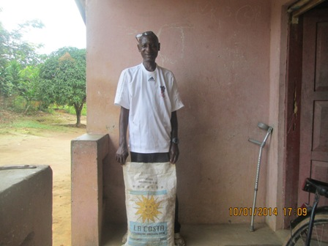
NEWTON AMPUTEE CAMP CHAIRMAN

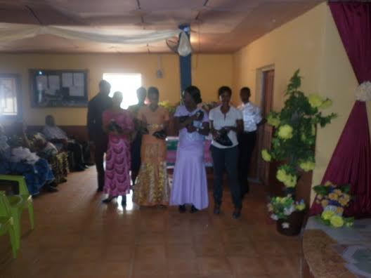
WILBERFORCE DISTRIBUTION
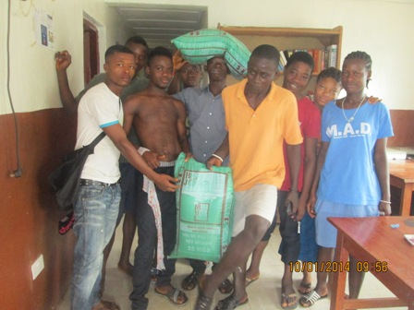
SOME OF KONDIE FARM YOUTH

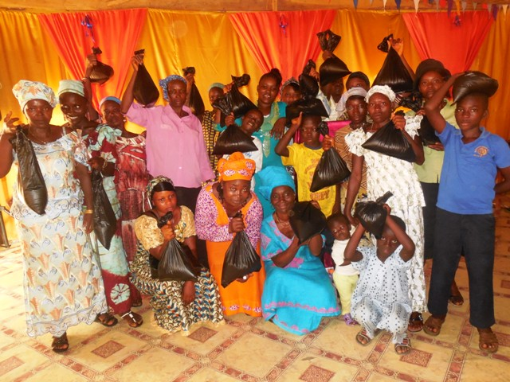
LUNGI DISTRIBUTION
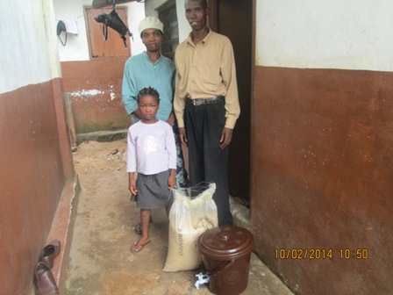
SORIE TOWN DISTRIBUTION
II.LIBERIA
3924 cases, 2210 deaths
The high number of infections in healthcare workers continues to be a cause of great concern, with 401 infected - of whom 232 had died, up to October 5.
A reported fall in new cases in Liberia is unlikely to be accurate, WHO says, "Rather, it reflects a deterioration in the ability of overwhelmed responders to record accurate epidemiological data. It is clear from field reports and first responders that EVD cases are being under-reported from several key locations..."
"Approximately 200 new probable and suspected cases, but very few confirmed cases, have been reported in the capital Monrovia in each of the past three weeks," the report adds.
"A substantial proportion of these suspected cases are most probably genuine cases of EVD, and the reported fall in confirmed cases over the past three weeks reflects delays in matching laboratory results with clinical surveillance data. Efforts continue to urgently address problems with data acquisition in what is an extremely challenging environment, and it is likely that the figures will be revised upwards in due course."
Giving a more detailed picture, the report goes on:
"The district of Margibi continues to report high numbers of new confirmed and probable cases (31 in the past week), while the district of Grand Cape Mount has reported new cases for the first time in three weeks. There continues to be a fall in the number of new cases reported in Lofa, which borders Gueckedou in Guinea, with 12 confirmed and probable cases reported this week compared with 39 the previous week. This appears to be a genuine reduction."
The Nigerian Army has revealed that about 1332 of its peace keeping troops in Liberia have been placed under surveillance following their contact with a Sudanese who later died of the Ebola Virus Disease (EVD).
CONCLUSION
According to the Pres. of SL we all need to focus on key items below for the future after this emergency response.
Sustainability: We know that the present Ebola Response is an emergency response but sustainability must be integrated into it in order to enable us to respond more quickly to a recurrence of the Ebola after this current one. The literature tells us that Ebola outbreak often recurs in all the countries that it had manifested itself. This would require the medium term transformation of makeshift centres into permanent ones; ongoing training of health personnel in the country; and establishment of a National Public Health Institute with surge capacities

Kick Starting the Economy: the disruptions to economic activities pose a major challenge in domestic revenue mobilization, investments, external trade and livelihoods. Therefore, the support of multilateral financial institutions is critical in addressing the emerging financing gaps in the fiscal and external sector accounts of affected countries. Support is needed to enhance post Ebola investments, restore livelihoods, prevent more suffering; and strengthen our capacity for partnerships in peace-building, for good governance, and socio-economic development.

